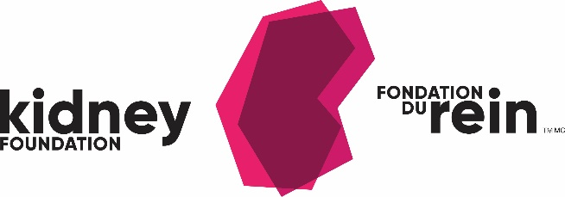

2022 Medal for Research Excellence

Nomination Form

SECTION 1: GENERAL INFORMATION

Nominee Information
Name:
Title:
Affiliation:
Address:
Telephone number:
E-mail address:

Nominator Information
Name:
Title:
Affiliation:
Address:
Telephone number:
E-mail address:

SECTION 2: CRITERIA

Reasons for nominating the above-mentioned individual must include reference to each of the criteria listed below. Please provide the information on separate sheets included with this nomination form (maximum of 5 pages).

In addition, please include a copy of the nominee’s current University curriculum vitae.

- How does the nominee’s kidney-related research exemplify excellence?
- How has the nominee’s research been transformative for the renal field? How has this research had an impact?
- What impact has the nominee had on the advancement of knowledge, and/or the improvement of patient care and/or training of investigators?
- The nominees’ metrics of productivity (i.e. understanding that each of these metrics of productivity may vary across specialties and disciplines and this will be taken into account. Please include all peer reviewed publications)
- The nominees’ achievements, awards and special acknowledgements.
- The nominees’ teamwork and team-building capabilities (i.e. has the nominee initiated, developed and nurtured a group of researchers?)
- An overview of most important research accomplishments.
- Any other pertinent information.

Please submit your nomination by email to:

Christine Marquis
Research Grants & Awards Manager
The Kidney Foundation of Canada
National Office
Email: christine.marquis@kidney.ca

Nominations must be received on or before Monday, January 31, 2022 at 8:00 pm EST.

Nominations received after the deadline will not be eligible for consideration.

